Software Requirements Specification

March 15, 2017

Periodic Table Program

Joshua Filer
Nick Martin
Vy Dinh
Jordan Geddes

Table of Contents

Table of Contents
Table of Contents i
1.0. Introduction 1
1.1. Purpose 1
1.2. Scope of Project 1
1.3. Definitions, acronyms, and abbreviations 2
1.4. References 3
1.5. Overview of Document 3
2.0. Overall Description 3
2.1 Product Perspective 3
2.2 Functional Requirements Specification 4
2.2.1 Element selection 4
2.2.2 Exiting the Program 4
2.2.3 Closing Element Display 4
2.3 User Characteristics 5
2.4 Constraints 5
3.0. Specific Requirements 6
3.1 External Interface Requirements 6
3.1.1 User Interface/Buttons 6
3.1.2 External Interfaces 7-8
3.2 Classes/Objects 8
Classes/Objects Diagram 8
Appendix: Data Flow of Program 9
Create Table Flow Chart 9
Refined High Level Flow Chart 10
Schedule of Project Plan/Outline of Roles/Requirements 11

1.0. Introduction

1.1. Purpose
The purpose of this document is to present a detailed description of an interactive three dimensional periodic table to allow students, teachers, and professors to explore a 3D shaped atomic nucleus of each different element.

1.2. Scope of Project
The software name for this product will be named, “Martin, Filer, Dinh, and Geddes’s 3D Periodic Table”. This software system will be a downloadable software application that will store all element and atomic information into a special database which will convert and display all information into a 3-dimensional periodic table. Since most students and professors would look up and research basic information of elements either from an online chemistry textbook or online search engine, this program will be designed to be a perfect substitute to allow easier access for students and professors to utilize the same level of research as online sources or books would do. Of course, the software system will be installed upon user request and would become a requirement for most biology and chemistry classes for most high schools and colleges.

This program is intended to be used by high schools and colleges such as University of Maryland with chemistry and biology classes at different levels, and it will take all inputs from clicks of students and professors to display the proper elements and nucleus models. Because of the periodic table model is allowed to be used by students and professors alike, there would be no login or administrative features as it will allow for equal use, without any security issues. Not only will this interactive periodic table be used for just colleges and schools in America, but for various schools and universities worldwide.

1.3. Definitions, acronyms, and abbreviations
Term | Definition
Periodic Table | A table of the chemical elements arranged in order of atomic number, usually in rows, so that elements with similar atomic structure (and hence similar chemical properties) appear in vertical columns.
Student | One who studies at a high school or college and utilizes all search engines and programs required for a class.
Teacher/Professor | A teacher on a certain subject at a high school or college specialized to teach a variety of students on a topic/subject.
Reservation | A room in a hotel or B&B that is reserved or guaranteed to a hotel guest for a specific period of time(from a certain date to another date as specified by the guest).
Element | A GUI representation of an element name with all specified information of that element.
Atom | A 3D model representation of all protons, neutrons, and electrons of an element’s nucleus.
GUI interface | A graphical user interface of the periodic table showing all of the different elements and names
Array List | The list storing all element names and information read from a file.
IEEE | Institute of Electrical and Electronics Engineers
JFrame | JFrames are swing components. A swing component is a part of a graphic user interface (GUI). Frames, windows, text boxes, buttons, switches and many other parts of a GUI application are all components.
User | Student, Teacher, or Professor.
Symbol | Letter Symbol of element
X and Y coordinate | Coordinates of vertical and horizontal dimensions of an element in the table
Mass | Mass of an Element
Create Table | Creates the JFrame, reads and creates elements, and plots elements in the frame.
Number | Atomic number of element
Mass | Mass number of an element

1.4. References
IEEE. IEEE Std 830-1998 IEEE Recommended Practice for Software Requirements Specifications. IEEE Computer Society, 1998.

Pradeepa, P. (2015). “Software requirements Specification.” LinkedIn Corporation. Retrieved from: http://www.slideshare.net/PreshanPradeepa/software-requirements-document

Gudavalli, K. (2013). “Software requirements specification.” LinkedIn Corporation. Retrieved from: http://www.slideshare.net/KrishnasaiGudavalli/software-requirements-specification-17173967

1.5. Overview of Document
The following chapters will provide the overall functionality of how this Periodic table program will operate for students and professors alike. The upcoming chapter will describe the general factors and provide background on the main functions that will be used for the system. All major technical functions will be described in detail in the Third chapter of this document.

- The third chapter, Requirements Specification section, of this document is written primarily for the developers and describes in technical terms the details of the functionality of the product.

- Following these chapters, there will be an appendix displaying the class diagram, low level flowchart, high level flowchart, and State-diagram to further explain the processes of the periodic table.

- Following the appendix, there will be a high level schedule of how the program will operate and what technologies would setup and store all aspects of the program.

2.0. Overall Description

2.1 Product Perspective
The Periodic table program is an independent, self-contained system with no support from websites, and of course not hooked to larger enterprises. Because of its independence and isolation from other enterprises,, the usability of the application will be very efficient for the user along with the speed of every process being efficient as it only functions from only Java applications, and not any SQL or other database credentials, which may slow the processes down greatly.
2.1.1 User Interfaces
- Table view: A Window that displays a periodic table grid and to allow a user to select an element to displays its credentials and 3D model.

- Model view: A window that displays the actual 3D model of the nucleus of a selected element and allows a user to scroll around the model to find all of its protons, neutrons, and electrons.

- Element information: A window that pops up after selecting an element to show off the atomic number, mass number, mole, and any other important element specifications.

2.2 Functional Requirements Specification
The functionality of the Periodic table can be broken into the following steps:

2.2.1 Element selection

Description: The user selects an element from the table view to view the element information and 3D model of the desired element.

Reference High Level Flow chart in Appendix: Data Flow of Program

2.2.2 Exiting the Program

Description: Once the user is done with the periodic table program, the user will hit the quit button, terminating the program.

Reference High Level Flow chart in Appendix: Data Flow of Program

2.2.3 Closing element display

Description: The user may be able to exit an element window if he/she feels that the element has been viewed enough, by pressing the close button in the element display. This would return the program to the main table display until the close button has been pressed.

Reference High Level Flow chart in Appendix: Data Flow of Program

2.3 User Characteristics
The users for the Periodic Table are the students and professors studying the elements and periodic table. They are accountable towards what element to select and study off of, and to view the atomic nucleus of each element from different angles at their discretion.
The students and professors are expected to know where each element is located on the periodic table, and briefly have an understanding of the differences between protons, electrons, and neutrons of an atom prior to figuring out how each element is displayed through a 3D model. They are also expected to know all the element’s figures and numbers prior to viewing all windows of element specifications, in which most cases the element specs may appear confusing to the users. Basically, scientific knowledge of the elements and periodic table is expected prior to using this interactive periodic table system.
A student is anyone of high school age to college age, who is expected to have some knowledge of periodic tables and element specs. A student must even know how to utilize computer programs and use the computer mouse effectively in order to navigate and utilize the computer program.
Professors are teachers of adult age and are expected to have full knowledge of the elements and periodic table to help teach students how to read periodic tables and element specs. Of course, the professor is expected to know how to use computers and the computer mouse effectively before attempting to use the periodic table program.

2.4 Constraints
- The Periodic table is only active with a computer that utilizes Java technology.

- The Periodic table requires mass memory to operate. A computer that has insufficient memory with this program installed would result in low performance of the program.

- The Periodic table program is only used on computers only, and not accessible for mobile and tablet platforms. Any Windows, Mac, or any third party computer would work to run this program, but it must have Java APIs and virtual machines installed in order for the program to work properly.

- All Periodic table elements must be stored in Array Lists and Array elements in order to provide maximum performance.

- Any User may access the Periodic table from any computer within a school or at a home computer as long as there is an Internet connection is present, and the program is downloaded from the site in which it was produced from.

2.5 Assumptions and dependencies
The following assumptions and dependencies are made for the Periodic Table program to operate properly:
- Oracle Java API and Java virtual machines are installed in the system to have the program operate properly.

- The institution or school, or home computer has an effective Internet connection in hand to allow the user to download and use properly at his/her own discretion.

- There is a work station or comfortable station available to access the computer and run this program properly.

- The computer system provides and ample amount of power and memory in order for the program to run efficiently and with fast speed for the users to have the best usage possible compared to any other program.

3.0. Specific Requirements

3.1 External Interface Requirements
The following are the requirements specific to the interaction between the software system, the users, and other components of the system:

3.1.1 User Interfaces/Buttons
- Table view: Includes the grid view of a periodic table. All windows to include the table menu will be displayed as a Windows Generated User Interface(GUI) Displays with Button listeners and JButtons to open, close, and select a certain element from the table, or close the program entirely. Also, certain listeners to allow the elements on the tables to act as button listeners must be encoded to allow the user to click a desired element and it would open up the Specification view and Model view. The tables and elements will also be created through loops based on the number of elements in the table.
Refer to the Create Table Flow Chart in the Appendix section: Data Flow of Program.

- Element databases: All elements should be inputted and displayed within arrays and array-lists to keep all data of the elements within storage for the program to uncover when the program is active. The arrays just need to accommodate for all of the parts and specifications of the elements in order to display all of the correct information when needed.

- Model view: Shows a display for the user to display the 3D model of the atom of a nucleus. Because of the 3D design of the nucleus and the effects of rotating around the 3D model of the nucleus, JavaFX and rotator listeners must be included to create the effects especially to allow the user to click and rotate around the nucleus model. All particles such as electrons, protons, and neutrons of the model should be coded in certain coordinates to carefully model off of the nucleus with all particles placed in the correct positions as specified how each atom model looks in text books and other forms of media. Any methods such as hard-coding or looping for correct positions should be considered when creating all atomic particles within the 3D model.

- Specification View: Shows after a user selects an element from the table and displays all of the specifications and numbers of the element selected. The view should incorporate not only a GUI window, but also include JButtons to hit okay to enter into the 3D model, and to also allow the user to close the window at his/her discretion. All specifications from a certain element must come from the array database and match the proper element selected. If else statements and switch statements should be used to help with selecting the proper specifications for the desired element selected.

- Close Buttons: JButtons that the users press to close out both an element window and of course the program. The close buttons should display and the program should follow with closing the window and returning back to the main table menu. In the table menu, if the close button is pressed, the program should have a message to confirm the closing of a program, and if the user selects confirm, the program should cancel out. On the other hand of the closing message, if the user selects “Cancel”, the program should stay fixed on the periodic table menu.

- Ok Buttons: JButtons that are incorporated in the specifications menu that would allow the user to close out the specification menu and open into the 3D model of the specified element. In any specification page of an element, the button should automatically close the Specifications view and automatically open the Model view for the viewers to see the desired element nucleus he/she has selected.

3.1.2 External Interfaces
- Mouse: Used by the user and the professor to scroll and select a desired element from the periodic table. The mouse will be a crucial component especially with the scrolling components involved with the Model View. Any mouse or scrolling pad on laptop computers will greatly qualify in making the rotator listeners function properly.

- Website Download: Used by the users to gain access to the Periodic Table program and downloading it to start viewing various elements. A website provided by the developers of this program should incorporate a downloadable link that downloads the main program onto a user’s primary computer from the website.

3.2 Classes/Objects
The following Diagram represents all classes and attributes that will be used for complete operation of the system. Every object will be generated in the system and methods are used in setting and retrieving certain requirements such as element specification windows, model windows, and all atom objects, which shall be set visible to the user upon request. Some objects will obtain certain attributes from other objects using getter methods to display important information such as atomic numbers as a primary key to reference what element should be displayed as selected by the user.

Some of the methods associated with the classes/objects such as createTable(), createElements(), and displayElement() will be utilized to set up the entire periodic table in the correct order as most periodic tables are set utilizing loops and arrays to provide all of the correct information in order and display it to the user. Please refer to the Flow chart documents in the Appendix to see what methods will be used to perform said functions.
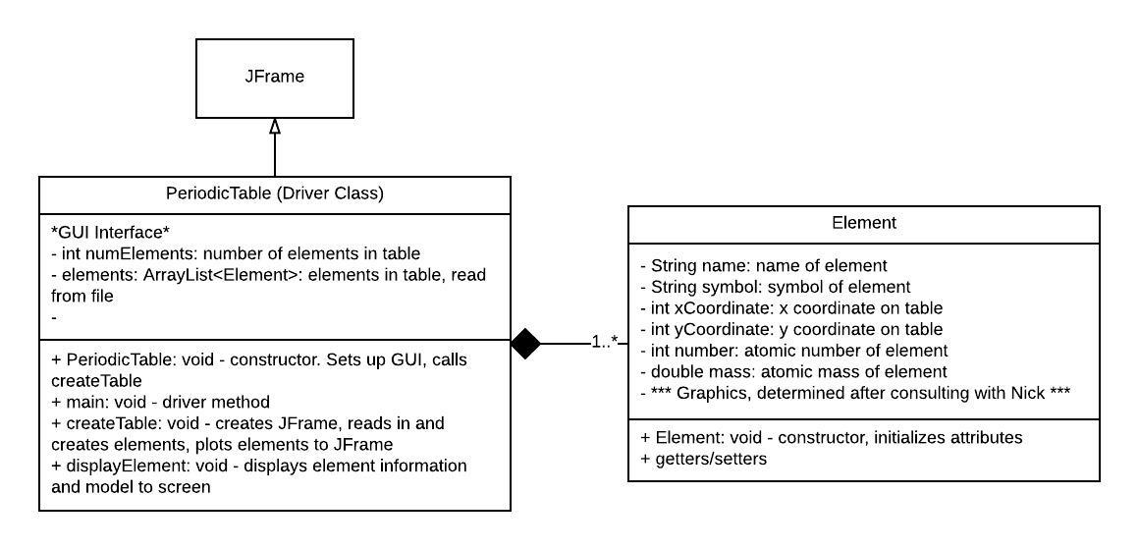
Classes/Objects Diagram

Appendix: Data flow of program

Create Table Flow chart
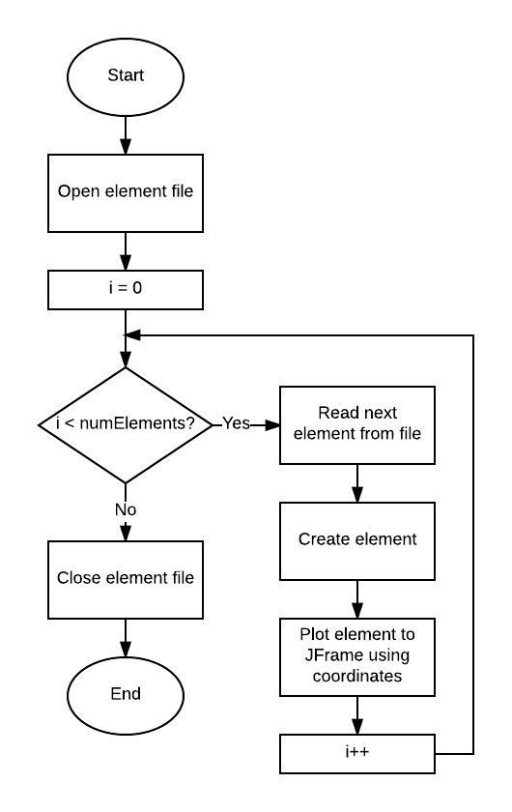

Refined High Level flow chart
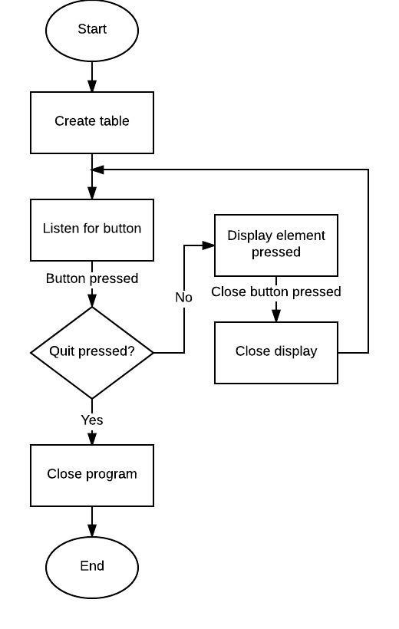

Schedule of Project Plan/Outline of Roles/Requirements:

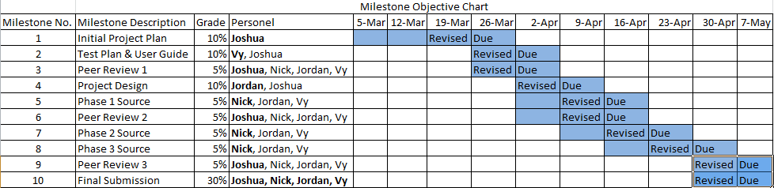

- This schedule depicts what should be accomplished each week. Blue represents mandatory requirements and the durations of how long each phase of the plan of the project should take. Each date at the top represents the end of each week and “Due” represents when a certain portion of the project should be complete.

- Most Important phases of the project should take about 2 weeks, just to allow for the second week to make any changes or final edits.

- All Programming codes and documentations should be shared via email and Github.com. For storage of all code must be done in GitHub.com to allow developers to look back, analyze, and edit code when necessary to make any corrections or revisions. The same goes for this document followed by all other important documentation for this project.

- For further information contact:

  - Joshua Filer: joshua.filer@yahoo.com
    - Roles: Project Plan/User Guide and Test Plan/Project Design/Final Submission
  - Nick Martin: nickmmartin@yahoo.com
    - Roles: Phase 1 Source/Phase 2 Source/Phase 3 Source/Final Submission
  - Vy Dinh: vydinh09@gmail.com
    - Roles: Test Plan and User Guide/Phase 1 source/Phase 2 Source/Phase 3 Source/Final Submission
  - Jordan Geddes: jgeddes101@gmail.com
    - Project Design/Phase 1 Source/Phase 2 Source/Phase 3 Source/Final Submission
  - All Developers would also partake in all Peer 1, Peer 2, and Peer 3 reviews.

